**MINI PROJECT – II**

**(Session 2018-19)**

**Group No. ……**

**SRS(**Software Requirements Specification**)**

**Ishtehaar**

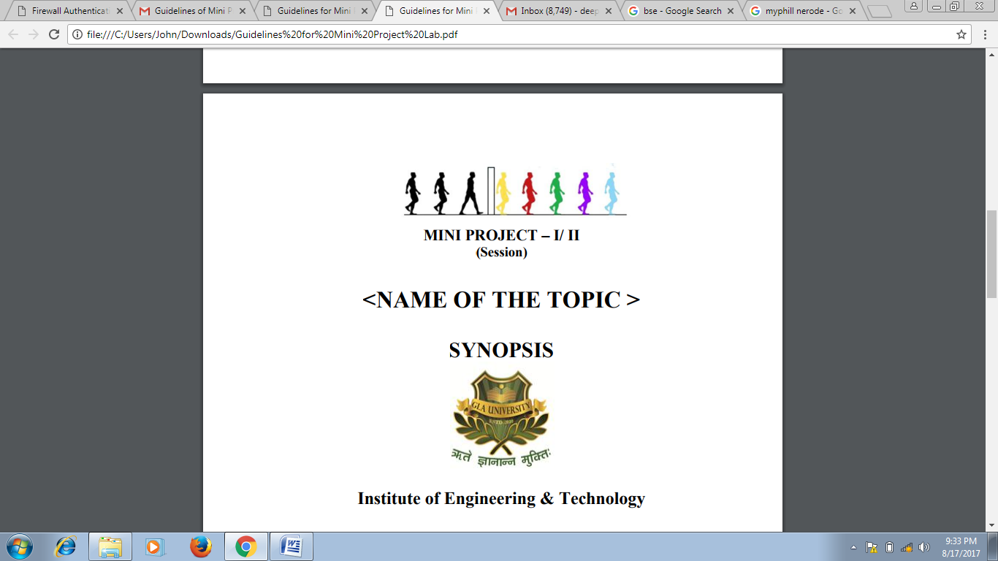

**Institute of Engineering & Technology**

**Team Members**

Nishant Kumar Singh

161500363

Rishabh Singh

161500452

Mukesh Kumar Maurya

161500330

**Supervised By**

Mr. Neeraj Khanna

Assistant Professor(Technical Trainer)

Department of Computer Engineering & Applications

# Table of Contents

1. Introduction 3

1.1 Purpose 3

1.2 Scope 3

1.3 Definitions, Acronyms, and Abbreviations 5

2. General Description 5

2.1 Product Perspective 5

2.2 Product Functions 5

2.3 User Characteristics 6

2.4 General Constraints 6

3. Specific Requirements 7

3.1 Use Cases 7

3.2 Data Flow Diagrams (DFD) 8

3.3 Non-Functional Requirements 9

3.3.1 Performance 9

3.3.2 Reliability 9

3.3.3 Availability 9

3.3.4 Security 9

3.3.5 Maintainability 9

3.3.6 Portability 10

# 

# 1. Introduction

**1.1 Purpose**

The Objective of Ishtehaar is to provide a platform for young graduates and freshers to find the right and satisfactory job according to their qualification.

It connects Job Seekers to recruiters by accurately matching candidate's profile to the relevant job openings through an advanced 2-way matching technology which works by matching candidates qualification to recruiters requirements.

Ishtehaar is developed with an eye to bridge the gap between talent and opportunities and offers end-to-end recruitment solutions. Ishtehaar brings candidate and top employees under one roof.

**1.2 Scope**

* Automate the process of finding the student and coder of the semester.
* Ranking the students on the basis of their skills and abilities.
* Each user has their own profile.

**1.3 Some important definitions**

**Android Studio: Android Studio** is the official integrated development environment (IDE) for Google's Android operating system, built on [JetBrains](https://en.wikipedia.org/wiki/JetBrains)' IntelliJ IDEA software and designed specifically for Android development.[[8]](https://en.wikipedia.org/wiki/Android_Studio#cite_note-8) It is available for download on Windows, macOS and Linux based operating systems. It is a replacement for the Eclipse Android Development Tools (ADT) as the primary IDE for native Android application development.

Android Studio was announced on May 16, 2013 at the Google I/O conference. It was in early access preview stage starting from version 0.1 in May 2013, then entered beta stage starting from version 0.8 which was released in June 2014. The first stable build was released in December 2014, starting from version 1.0.[]](https://en.wikipedia.org/wiki/Android_Studio#cite_note-12) The current stable version is 3.3, which was released in January 2019

**SQLite :** SQLite is a C-language library that implements a small, fast, self-contained, high-reliability, full-featured, SQL database engine. SQLite is the most used database engine in the world. SQLite is built into all mobile phones and most computers and comes bundled inside countless other applications that people use every day.

**UML** : UML, **Unified Modeling Language (UML)** is a general purpose modelling language. The main aim of UML is to define a standard way to **visualize** the way a system has been designed. It is quite similar to blueprints used in other fields of engineering.

UML is **not a programming language**, it is rather a visual language. We use UML diagrams to portray the **behavior and structure** of a system. UML helps software engineers, businessmen and system architects with modelling, design and analysis. International Organization for Standardization (ISO) published UML as an approved standard in 2005. UML has been revised over the years and is reviewed periodically. UML is linked with **object oriented** design and analysis. UML makes the use of elements and forms associations between them to form diagrams

**User :** It is the person who will be using the software to generate the software and use all of the other features of the software.

**XML:XML** stands for eXtensible Markup Language. **XML** is a markup language much like HTML. **XML** was designed to store and transport data. **XML** was designed to be self-descriptive. **XML** is a W3C Recommendation.

**1.4 Tools Used**

Android Studio: Android Studio is the official integrated development environment (IDE) for Google's Android operating system, built on JetBrains' IntelliJ IDEA software and designed specifically for Android development.[8] It is available for download on Windows, macOS and Linux based operating systems. It is a replacement for the Eclipse Android Development Tools (ADT) as the primary IDE for native Android application development

**Github :**GitHub Inc is a web-based [hosting service](https://en.wikipedia.org/wiki/Internet_hosting_service) for [version control](https://en.wikipedia.org/wiki/Version_control) using [Git](https://en.wikipedia.org/wiki/Git). It is mostly used for [computer code](https://en.wikipedia.org/wiki/Source_code). It offers all of the [distributed version control](https://en.wikipedia.org/wiki/Distributed_version_control) and [source code management](https://en.wikipedia.org/wiki/Source_code_management) (SCM) functionality of Git as well as adding its own features. It provides [access control](https://en.wikipedia.org/wiki/Access_control) and several collaboration features such as [bug tracking](https://en.wikipedia.org/wiki/Bug_tracking_system), [feature requests](https://en.wikipedia.org/wiki/Software_feature), [task management](https://en.wikipedia.org/wiki/Task_management), and [wikis](https://en.wikipedia.org/wiki/Wiki) for every project.

**Chrome :**Google Chrome is a freeware web browser developed by [Google LLC](https://en.wikipedia.org/wiki/Google_LLC).

**1.5 Some Acronyms**

* API- Application Program Interface
* App – Application

**1.6 References**

• International Journal of Scientific and Research Publications, Volume 5, Issue 1,

January 2015 1 ISSN 2250-3153.

• Software Engineering, seventh edition, Roger S. Pressman.

• Software Engineering, Seventh Edition, Ian Somerville.

• Hans van Vliet. Software Engineering: Principles and Practice (Second Edition).

.

# 2. General Description

## 2.1 Product Perspective

Ishtehaar app is independent and self-contained. An integrated data base will ensure the storage and the retrieval of the user related information . It will be the product that allows people to do work with their suitable profession.

## 2.2 Product Functions

* **Register** – The user must register once in order to get access to the application; after registering, a unique user name and password will be provided and will allow the logging in of the registered user.
* **Log-in** – A registered user has to enter his/her unique user name/password combination in order access the application.
* **Data :** Userenter their information related to their skills, project and cultural activities**.**

## 2.3 User Characteristics

* **Types of Users**
* Employee
* Job seeker
* **Technical expertise:**All users needs to have minimal technical expertise (need to know the use of web application)

**2.4 Constraints**

•**Platform:** One can download this app from Google play store or apk is available on the website.

• **Operating system:**Support all android version above kitkat.

•GUI is only in English.

•Login and password is used for the identification of users

**Tools & Languages Used**

* **Language Used: -**
  + Java
  + XML
  + SQLite
* **Software Used: -**
  + Android Studio
  + GitHub

# 3. Specific Requirements

**3.1 Data Flow Diagram :**



**Employee:** The Employee is main user of this application where he/she can update information of job seeker who are looking for employment

**Job Seeker:** Those who really looking for employment can registered with their specific skills and Requirement.

**Login**:Interested candidate can login and apply for specific jobs according to their skills.

**Search Job**:One can search job according to his choice.

**Update Profile**:User can update Profile whenever they want.

**3.2 Data Flow diagram(DFD) :**

**3.3 ER Diagram :**

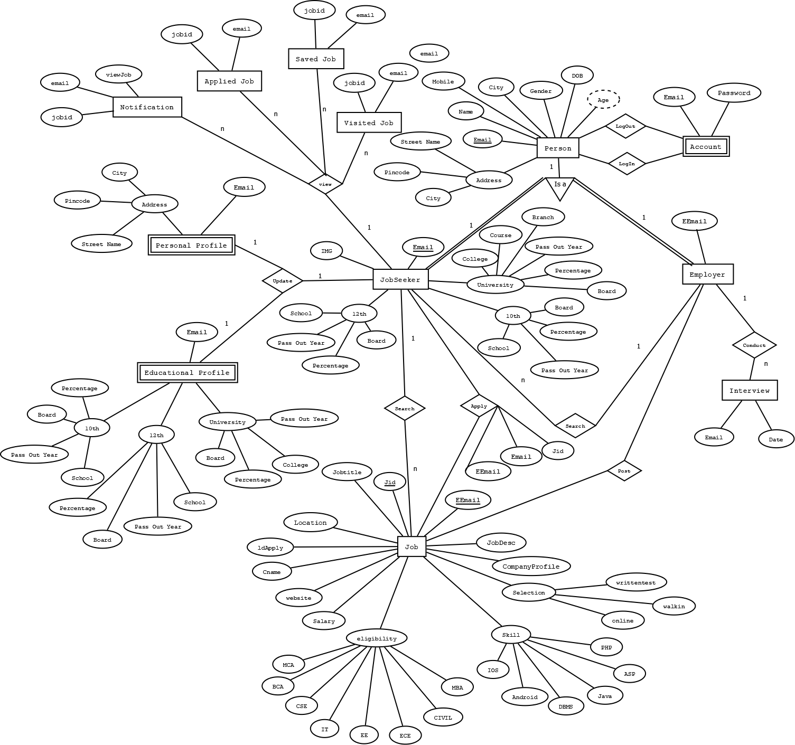

**3.3 Software System Attributes**

**3.3.1 Reliability**

The system will not crash on invalid data files or input files. If video files are uploaded in a format that is not recognized, the system will ask the user to recode the file in the correct format or the system will produce an error (refer to section 3.5.4 Maintainability for adding data files). The data files will be stored on a nonvolatile storage device such as a hard drive(basically sever), so that the data files can be retained when the system is shut off. The system will check the validity of the user files when they are loaded. If there is an error the system will ask the user to check his/her account. If there is a fatal error the system shuts down without crashing the system it is running on.

**3.3.2 Availability**

The system will only run infrequently. The system will allow the user to restart the application after a crash. All data beyond the last save point will be lost. The user will be able to load his or her data file after the system has been restarted and continue using the system. The system will have an average run time of 15 to 20 min per session(it can be modified by the admin on consult) depending on the user, although the user may use the system longer.

**3.3.3 Security**

The system will use the computer’s default operating system security. The system will not use any of its own security features since the software is not web-based and it is going to be run over a network. The system will be contained on one android biased operating system. The data files will be encrypted since the data stored in firebase is sent in an encrypted format. The system checks the validity of the data files when it is running and if the data is invalid the system outputs an error to the user. The system will not keep log files of the User’s usage.

**3.3.4 Maintainability**

The admin will be able to update the system with new features and updates. The system will ask the user to specify the videos, audios, photo, will be stored to the database. To add a video, photo (image) it must be put in this directory and there must be a corresponding data file for the video, image. The corresponding data file will contain information about the complaint in the form of text, image, video and audio where the user can put this along with information of complain. The product will be built using components that are as independent as possible to make the system easily modifiable. All components of the system will be modular and be as independent as possible. Each component will have a different function, GUI. Users will be able to add new content with each complaint. The system will allow the higher authority to be notified about the problem faced by the individual in the campus.

**3.3.5 Portability**

The product will be able to run on Android Operating system. The software will be written in a platform independent programming language for portability; there will be no platform specific code. We will write all the software using Java. All the video files will be in mp4 and above format that can be played back on android operating system. We will use the android Media Framework for support of the playback of video files. The system’s data files will be portable for android operating system. The user will have to install the required application on the system. The system will also require that the Android Runtime Environment (ART) with latest version.